**Experiment: 1**

Student Name : Prateek Sharma

Roll Number: A50105221015

Semester /Section: 3rd sem/ A

Date:

Faculty Signature:

Remarks:

__________________________________________________________________________________

**Write a program to sort an array using Bubble sort**

#include<iostream>

using namespace std;

int main()

{

int n, i, arr[50], j, temp;

cout<<"Enter the Size : ";

cin>>n;

cout<<"Enter "<<n<<" Numbers: ";

for(i=0; i<n; i++)

cin>>arr[i];

for(i=0; i<(n-1); i++)

{

for(j=0; j<(n-i-1); j++)

{

if(arr[j]>arr[j+1])

{

temp = arr[j];

arr[j] = arr[j+1];

arr[j+1] = temp;

}

}

}

cout<<"\nSorted Array is: \n";

for(i=0; i<n; i++)

cout<<arr[i]<<" ";

cout<<endl;

return 0;

}

Output:

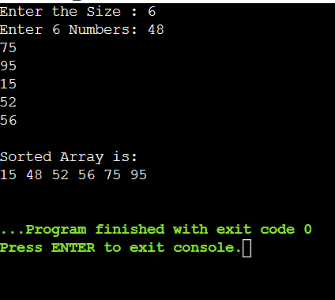

**Experiment: 2**

Student Name : Prateek Sharma

Roll Number: A50105221015

Semester /Section: 3rd sem/ A

Date:

Faculty Signature:

Remarks:

**Write a program to sort an array using Insertion sort**

#include<iostream>

using namespace std;

int main()

{

int arr[50], n;

int i, j, k, elem, index;

cout<<"Enter the Size for Array: ";

cin>>n;

cout<<"Enter "<<n<<" Array Elements: ";

for(i=0; i<n; i++)

cin>>arr[i];

for(i=1; i<n; i++)

{

elem = arr[i];

if(elem<arr[i-1])

{

for(j=0; j<=i; j++)

{

if(elem<arr[j])

{

index = j;

for(k=i; k>j; k--)

arr[k] = arr[k-1];

break;

}

}

}

else

continue;

arr[index] = elem;

}

cout<<"\nThe New Array Sorted Array By Insertion Sort:\n";

for(i=0; i<n; i++)

cout<<arr[i]<<" ";

cout<<endl;

return 0;

}

Output:

